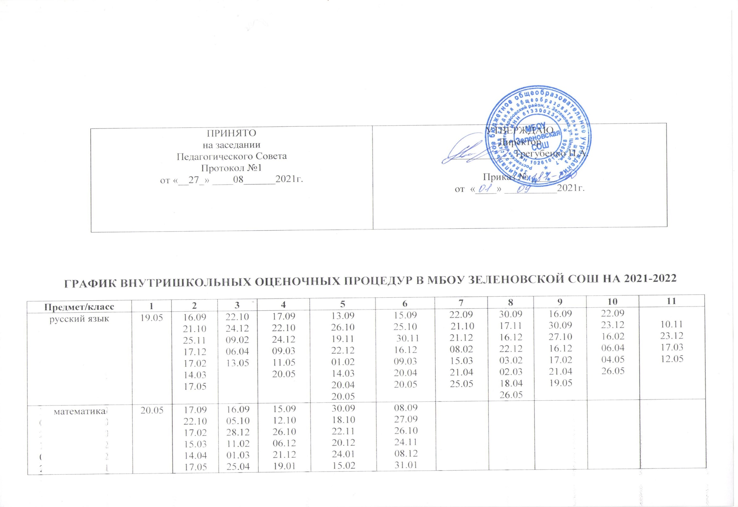
математика |  | 14.04  17.05 | 01.03  25.04 18.05 | 21.12  19.01  15.03  26.04  23.05 | 24.01  15.02  14.03  15.04  26.05 | 08.12  31.01  16.03  14.04  17.05
алгебра |  |  |  |  |  |  | 04.10  15.11  20.12  31.01  14.02  18.03  11.05  20.05 | 03.09  15.10  29.11  17.01  28.02  13.04  11.05  25.05 | 08.09  10.12  24.01  16.02  06.04  13.05 | 08.10  10.11  13.12  28.01  04.04  13.05 | 10.09  04.10  12.11  22.12  09.02  06.04  06.05
геометрия |  |  |  |  |  |  | 05.10  07.12  01.02  24.02  19.04  26.05 | 19.10  14.12  20.01  01.03  12.05 | 19.10  02.12  01.02  17.03  28.04 | 15.10  25.11  17.02  14.04  12.05 | 23.09  19.10  16.12  24.02  05.04
литература | 16.05 | 20.09  18.10  21.12  21.03  13.05 | 10.09  13.10  23.12  03.03  20.04  05.05 | 13.09  25.10  22.11  20.12  19.05 | 08.09  24.11  24.12  02.03  11.04  28.05 | 09.09  22.12  17.03  25.05 | 30.11 18.01  11.03  20.05  27.05 | 27.09  15.11  01.12  05.03  27.04 | 01.12  28.01  11.04 | 18.09  08.12  21.05 | 09.09  15.11  27.12  18.03  17.05
английский яз |  | 25.10  20.12  17.03  19.05 | 13.09  25.10  22.12  16.03  23.05 | 14.09  26.10  24.12  18.03  24.05 | 09.09  27.10  23.12  17.03  27.05 | 10.09  28.10  24.12  18.03  27.05 | 26.10  27.12  21.03  30.05 | 27.10  24.12  18.03  27.05 | 28.10  24.12  18.03  20.05 | 27.10  23.12  17.03  26.05 | 26.10  27.12  21.03  24.05
информатика |  |  |  |  |  |  | 12.11.  24.12.  04.02.  15.04.  16.05 | 08.09.  08.12.  02.03.  11.05.  18.05. | 20.09.  22.11.  17.01.  05.03.  16.05 | 09.09.  24.11.  23.12.  28.04.  27.05 | 15.09.  11.10.  22.12.  13.04.  16.05
физика |  |  |  |  |  |  | 25.11  23.12  24.02  17.03  24.05 | 21.10  02.12  12.04  28.04  24.05 | 07.12  25.01  17.03  28.04 | 07.10  18.11  21.12  03.03  17.05 | 26.10  08.02  07.04  24.04  19.05
астрономия |  |  |  |  |  |  |  |  |  |  | 21.10  16.12  25.02  21.04
химия |  |  |  |  |  |  |  | 25.10  21.12  21.02  25.04  21.05 | 15.09  20.10  09.02  20.04  18.05 | 09.09  16.12  03.03  21.04  19.05 | 13.10  22.12  11.03  29.04
Биология  Окр мир |  | 09.09 25.11  12.01  16.03 12.05 | 15.09  21.12  16.03  18.05 | 16.09  27.10  22.12  17.03  12.05 | 15.09  24.11  09.03  18.05 | 20.09  13.12 28.02  18.04  16.05 | 13.09  22.11  07.02  04.04  23.05 | 18.12  07.04  26.05 | 14.10  23.12  10.03  16.05 | 22.10  24.12  18.05 | 25.01  16.05
география |  |  |  |  | 22.10  11.03  13.05 | 14.09  23.11  15.03  17.05 | 29.09  24.12  04.03  20.04  27.05 | 10.09  04.03  27.05 | 13.09  24.11  12.01  16.03  11.05 | 24.01  25.04 | 25.10  27.12  10.05
история |  |  |  |  | 28.09  26.10  14.12  10.03  26.05 | 13.09  13.12  27.12  11.04  25.05 | 15.09  08.11  13.12  14.03  25.05 | 15.09  27.10  10.12  16.03.  20.05 | 10.09  22.10  03.12  04.03  19.05 | 15.09  21.10  22.12  17.03  25.05 | 14.09  29.10  16.11  22.03  13.05
обществознание |  |  |  |  |  | 03.12  06.05 | 16.09  17.02  12.05 | 12.10.  14.12. 08.02.  24.05. | 15.10.  17.12.  15.04.  13.05. | 26.10.  24.12.  03.05. 20.05. | 07.12.  01.02.  26.04.  20.05.
ОДКНР |  |  |  |  | 17.12  20.05 | 09.12  12.05

